**Light Rail System**

**Software Design Description**

**Version <1.0>**

Contents

1. Overview 2

1.1. Scope 3

1.2 Purpose 3

1.3 Intended Audience 3

1.4 Conformance 3

1.5 References 3

2. Definitions 3

3. Conceptual Model for Software Design Descriptions 4

3.1 Software Design in Context 4

3.2 Software Design Descriptions Within the Life Cycle 5

4. Design description information content 5

4.1 Introduction 5

4.2 SDD identification 5

4.3 Design stakeholders and their concerns 5

4.4 Design views 5

4.5 Design viewpoints 5

4.6 Design elements 6

4.7 Design overlays 6

4.8 Design rationale 6

4.9 Design languages 6

5. Design viewpoints 6

5.1 Introduction 7

5.2 Context viewpoint 7

5.2.1 CTC Office 7

5.2.1.1 Use Case Description 7

5.2.1.2 Use Case Diagram 7

5.2.2 Wayside Controller 8

5.2.2.1 Software 9

5.2.2.1.1 Use Case Description 9

5.2.2.2 Hardware 10

5.2.2.1.1 Use Case Description 10

5.2.2.1.2 Use Case Diagram 10

5.2.3 Track Model 11

5.2.3.1 Use Case Description 11

5.2.3.2 Use case Diagram 11

5.2.4 Train Model 12

5.2.4.1 Use Case Description 5.2.4.2 Use Case Diagram 13

5.2.5 Train Controller 15

5.2.5.1 Use Case Description 15

5.2.5.2 Use Case Diagram 16

5.3 Composition viewpoint 16

5.3.1.1 Deployment Diagram 16

5.4 Logical viewpoint 17

5.4.1 CTC Office 17

5.4.1.1 Class Diagram 18

5.4.2 Wayside Controller 18

5.4.2.1 Software 19

5.4.2.1.1 Class Diagram 19

5.4.2.2 Hardware 19

5.4.2.2.1 Class Diagram 20

5.4.3 Track Model 20

5.4.3.1 Class Diagram 21

5.4.4 Train Model 21

5.4.4.1 Class Diagram 22

5.4.5 Train Controller 23

5.4.5.1 Class Diagram 24

5.5 Dependency viewpoint 24

5.5.1 CTC Office 24

5.5.1.1 System Architecture 25

5.5.2 Wayside Controller 25

5.5.3 Track Model 26

5.5.3.1 System Architecture 26

5.5.4 Train Model 26

5.5.4.1 System Architecture 27

5.5.5 Train Controller 27

5.5.5.1 System Architecture 27

5.6 Information viewpoint 28

5.7 Patterns use viewpoint 28

5.8 Interface viewpoint 28

5.8.1 CTC Office 28

5.8.1.1 Dispatcher UI 29

5.8.2 Wayside Controller 29

5.8.2.1 Software 30

5.8.2.1.1 Test User Interface 30

5.8.2.1.2 User Interface (Programmer’s) 30

5.8.2.2 Hardware 31

5.8.2.2.1 Test User Interface 32

5.8.2.2.2 User Interface 32

5.8.3 Track Model 32

5.8.4 Train Model 34

5.8.4.1 Test User Interface 34

5.8.4.2 Train Model User Interface 34

5.8.5 Train Controller 34

5.8.5.1 Engineer’s UI: 34

5.9 Structure viewpoint 34

5.10 Interaction viewpoint 34

5.10.1 CTC Office 34

5.10.1.1 Sequence Diagram 34

5.10.2 Wayside Controller 34

5.10.2.1 Software 34

5.10.2.1.1 Sequence Diagram 34

5.10.2.2 Hardware 34

5.10.2.2.1 Sequence Diagram 34

5.10.3 Track Model 34

5.10.3.1 Sequence Diagram 34

5.10.4 Train Model 34

5.10.4.1 Sequence Diagram 34

5.10.5 Train Controller 34

5.10.5.1 Sequence Diagram 34

5.11 State dynamics viewpoint 34

5.12 Algorithm Viewpoint 34

5.12.1 CTC Office 34

5.12.1.1 Apportionment 34

5.12.2 Wayside Controller 34

5.12.2.1 Apportionment 34

5.12.3 Track Model 34

5.12.3.1 Apportionment 34

5.12.4 Train Model 34

5.12.4.1 Apportionment 34

5.12.5 Train Controller 34

5.12.5.1 Apportionment 34

5.13 Resource viewpoint 34

6. System Architecture 34

6.1 Route 34

6.2 Authority 34

6.3 Wayside Distribution 34

6.4 Timing 34

6.5 Vitality 34

1. Overview

## 1.1. Scope

This document contains the high-level requirements for the **renovated Centralized Traffic Control Center (CTC) and Signaling System for Light Rail Transit System.** This standard represents the software design used for simulating transit of the Light Rail Transit system, dispatching trains from Brookline to PNC Park in Pittsburgh, Pennsylvania. This system will be demonstrated on any commercial computer supporting Windows 10 operating system (OS). This system will be demonstrated to the president of the Pittsburgh Regional Transit's system—the Port Authority of Allegheny County (PAAC) — to be adopted and used by other stakeholders, such as the Transportation Security Administration (TSA) as well as the National Transportation Safety Board (NTSB) for monitoring and safety regulation. Each design concern of the stakeholders is the topic of required design views which are modeled by Unified Modeling Language (UML) diagrams. This standard is prepared according to the IEEE 1016 standards.

## 1.2 Purpose

The purpose of this document is to describe the design of the software for the **renovated Centralized Traffic Control Center (CTC) and Signaling System for Light Rail Transit System** for future software design to proceed and how the process of it develops once the system is adopted. The topics of general description of design elements and their interactions, how the system will be structured, and data & functional structure are further discussed to help produce use cases, maintenance services, and satisfy requirements indicated in the SRS document.

## 1.3 Intended Audience

This standard is intended for technical and managerial stakeholders who prepare and use the **renovated Centralized Traffic Control Center (CTC) and Signaling System for Light Rail Transit System**. This standard shall be used as a guide in the selection, organization, and presentation of design information. The use of this standard can help to ensure design descriptions are complete, concise, consistent, interchangeable, appropriate for recording design experiences and lessons learned, well organized, and easy to communicate with all stakeholders.

1.4 Conformance   
 This standard satisfies all the requirements listed in Section 4 and Section 5. Requirements are denoted by the verb shall.

## 1.5 References

[1] IEEE. IEEE Std 1016-2009 IEEE Standard for Information Technology – System Design – Software Design Descriptions. IEEE Computer Society, 2009

[2] Middle East Technical University. <https://senior.ceng.metu.edu.tr/2015/musinspro/MusIns-Pro_SDD.pdf>

# 2. Definitions

|  |  |
| --- | --- |
| Use Case Diagram | A type of static structure diagram in UML that describes user's interaction with the system |
| Class Diagram | A type of static structure diagram in UML that describes the structure of a system by showing the system's classes, their attributes, operations (or methods), and the relationships among the classes |
| Sequence Diagram | A type of static structure diagram in UML which describes a group of objects that are represented by lifelines, and the messages that they exchange over time during the interaction. |
| Deployment Diagram | A type of static structure diagram in UML which shows the relationships between the software and hardware components in the system and the physical distribution of the processing; Typically used to visualize the physical hardware and software of a system. |
| IEEE Standard | International Electric Electronic Engineering Standards 1016 |
| SDD | Software Design Description |
| SRS | Software Requirement Specification |
| Stakeholders | Any person with an interest in the system who is not a developer of the system. |
| StarUML | Design tool of UML diagrams |
| IDE | Integrated Development Environment |
| User | Person who wants to use the system |
| User Interface | An interface that the system contacts with the user of the system. It gets all the information needed for its running, from users to the system. |
| Centralized Traffic Control Center (CTC) | From the office dispatchers control the transit system; Schedule, monitor and route trains, close and open track sections for maintenance, set authority of trains, show current state of entire transit system |
| Wayside Controller | Controls the track; Communicates with CTC office to control switching of the track, railway crossings, detect broken rails or presence of trains and reports back state of the system to the CTC. Runs a PLC program written by the user |
| Track Model | Represents the transit system track layout; Determines allowable directions of travel, branching and speed limits, enable track circuits for presence detection and failure detection |
| Train Model | Models train movement using Newton’s laws assuming the train as a point mass and accounting for the terrain of the track; Shows information regarding state of the train and should detect failures |
| Train Controller | Controls the train; Regulates speed of the train to the setpoint while not exceeding the speed limit or authority allowed by the system, operates the train according to input from a Transit operator, and monitors faults which are acted upon in a safe manner |

# 3. Conceptual Model for Software Design Descriptions

This section establishes a conceptual model for the **renovated Centralized Traffic Control Center (CTC) and Signaling System for Light Rail Transit System**. The conceptual model includes use-case, class, sequence and deployment diagrams (shown in later sections), the stakeholders at PAAC who use them upon adoption of the new transit system, and how they shall be used. The purpose of conceptual model is to give a better understanding of system terminology and software life cycle that the system resides on. The conceptual model also gives information about stakeholders who will use SDD and how the SDD will be used

## 3.1 Software Design in Context

The **renovated Centralized Traffic Control Center (CTC) and Signaling System for Light Rail Transit System** will be structured as object-oriented in a modular design fashion. The system will be implemented with Python using PyCharm as the IDE. The system will try to give the most accurate result in the most applicable, proper and correct time with both its software and hardware implementations; so, it can respond to users’ wants correctly and quickly. It should respond correctly and quickly with user interface and user input recognition. The speed of the software implementation of the system depends on the computational operations according to processor(s) of computer that runs Windows 10 operating system.

The **renovated Centralized Traffic Control Center (CTC) and Signaling System for Light Rail Transit System** is planned to be an application on the system in personal computers which supports Windows 10. With its Arduino hardware component, the **renovated Centralized Traffic Control Center (CTC) and Signaling System for Light Rail Transit System** will be a standalone application. Also, with portability and adaptability, the system can be ported to different platforms, assuming they support Windows 10.

## 3.2 Software Design Descriptions Within the Life Cycle

This software will be created following IEEE 1016 standard. The primary milestones of this system are requirements analysis, design description analysis, implementation and finally verification and validation.

# 4. Design description information content

## 4.1 Introduction

This section analyzes how the system will be designed and implemented for the **renovated Centralized Traffic Control Center (CTC) and Signaling System for Light Rail Transit System**. This section investigates these according to identification of the SDD, identified design stakeholders and design concerns, related design viewpoints, design views, overlays, rationale and languages. Furthermore, this section includes design elements which are design entities, attributes, relationships and constraints.

## 4.2 SDD identification

The **renovated Centralized Traffic Control Center (CTC) and Signaling System for Light Rail Transit System** will be released by the end of April 2023, after validation and verification tests. The prototype of the system will be shown at the beginning of April 2023. Scope, references, context and summary can be found under the section “Overview”. Glossary can be found under the section “Definitions, Acronyms and Abbreviations”.

## 4.3 Design stakeholders and their concerns

Stakeholders comprise a developer team which is **Light Rail Transit System** located in Pittsburgh, PA. The main concerns of the stakeholders are the quality of design, safety critical measures, vitality, maintainability, and minimal deployment cost.

## 4.4 Design views

Design views help design stakeholders focus on design details from a specific perspective to meet relevant requirements. Each identified design concern must be topic of at least one design view so that SDD is complete. Each design concern identified in the previous subsection is the topic of most of the design views in this document; thus, this SDD is completed. For example, concerns about cost are topic of composition view. Moreover, concerns about quality of design are topic of logical view. In this section, context, composition, logical, dependency, information, patterns use, interface, and interaction views will be explained in section 4.5 as their corresponding viewpoints. For some views, relevant UML diagrams will be shown in later sections for clarification.

## 4.5 Design viewpoints

This section describes context, composition, logical, dependency, information, patterns use, interface, structure, and interaction viewpoints.

***Context Viewpoint:***It describes the relationships, dependencies and interactions between the system and its environment such as users and other interacting stakeholders. Interactions between the system and its actors are very intense, hence concerns of this viewpoint is important and suitable for **Light Rail Transit System**. It includes use cases for context along with use case diagrams showing the system boundary.

***Composition Viewpoint:*** It describes how the design subject split up into its sub-systems and which roles these modules have. It can be used in estimating costs, staffing and scheduling duties of the development team. It includes a deployment diagram for each module.

***Logical Viewpoint:*** It describes class structures, interactions between them and how they are designed and implemented. Also, it supports development and reuse of existing logical components. It includes a class diagram for each module which defines objects and classes, and relationships between them.

***Dependency Viewpoint:*** It describes the components of the system and dependencies between these components. It gives information about shared information and order of execution of these components.

***Information Viewpoint:*** It describes data items, data types and classes, data stores and access mechanisms. It gives information about data attributes.

***Patterns Use Viewpoint:*** It describes design patterns and usage of design patterns which meet design ideas of the project.

*Interface Viewpoint:* It describes the details of external and internal interfaces. It provides information to the designers, programmers and testers before proceeding with the detailed design of the system. This also allows designers, programmers and testers to use the system as a user.

***Interaction Viewpoint:*** It describes the sequence of actions and how, why, where and at what level actions occur in the system.

## 4.6 Design elements

Any item which appears in a design view is named as design elements. It may be one or some of these subcases; design entity, design relationship, design attribute and design constraints. All design elements are defined with subcases under their corresponding viewpoint in section 5 of the software design description.

## 4.7 Design overlays

Design overlays are usually used to add information to the existing views. This concept will be explained clearly, when necessary, in the design viewpoints section which is 5.

## 4.8 Design rationale

An Object-Oriented structure using Python was chosen while designing because in this way hardware part and software part will be combined easily. This also makes the entire system integration and sub-system communication between modules easier. The software part includes transmitting data between modules through an Application Product Interface (API) via signals in a Python executable. To design each module, Python packages, such as pyqt5, were used. These packages are connected between each other, and they can be controlled separately. Furthermore, for the hardware part a selection of packages compatible with the Arduino device is used.

## 4.9 Design languages

In this document Unified Modeling Language (UML) is used as the modeling language for the diagrams. The modeling language is used for emphasizing the static structure and dynamic behavior of the system.

# 5. Design viewpoints

## 5.1 Introduction

This section provides several main design viewpoints of the **renovated Centralized Traffic Control Center (CTC) and Signaling System for Light Rail Transit System** with the corresponding design concerns and appropriate design languages. Respectively, context, composition, logical, dependency, information, patterns, interface, structure and interaction viewpoints are defined in the following subsections. Short descriptions relating a minimal set of design entities, design relationships, design entity attribute, and design constraints are provided for each viewpoint.

## 5.2 Context viewpoint

The context viewpoint of the **renovated Centralized Traffic Control Center (CTC) and Signaling System for Light Rail Transit System** software shows the functions provided by a design subject with reference to an explicit context. The services are the functions, which describes the relationships, dependencies, and interactions between the system and its environment like users and other stakeholders

## 5.2.1 CTC Office

## 5.2.1.1 Use Case Description

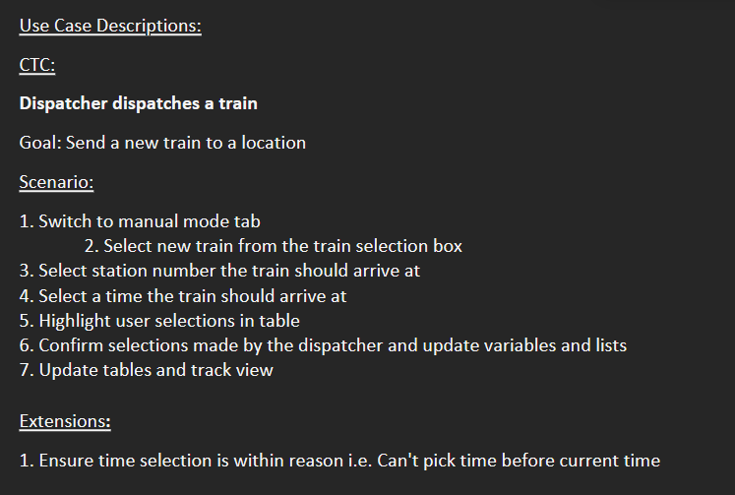

## 5.2.1.2 Use Case Diagram

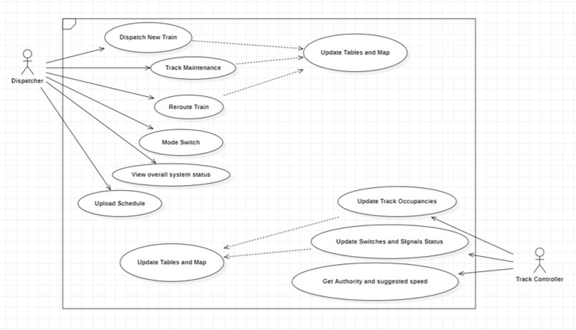

## 5.2.2 Wayside Controller

## 5.2.2.1 Software

## 5.2.2.1.1 Use Case Description

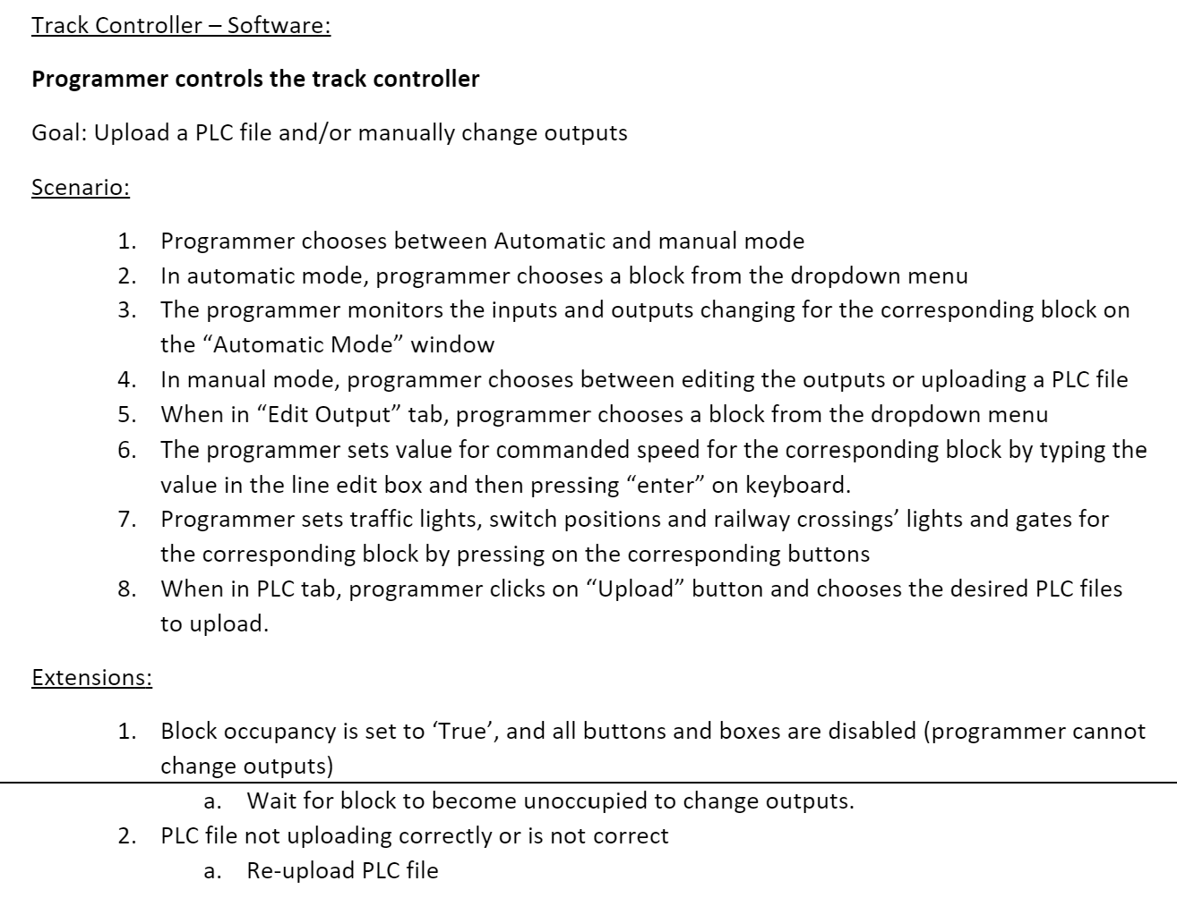 5.2.2.1.2 Use Case Diagram

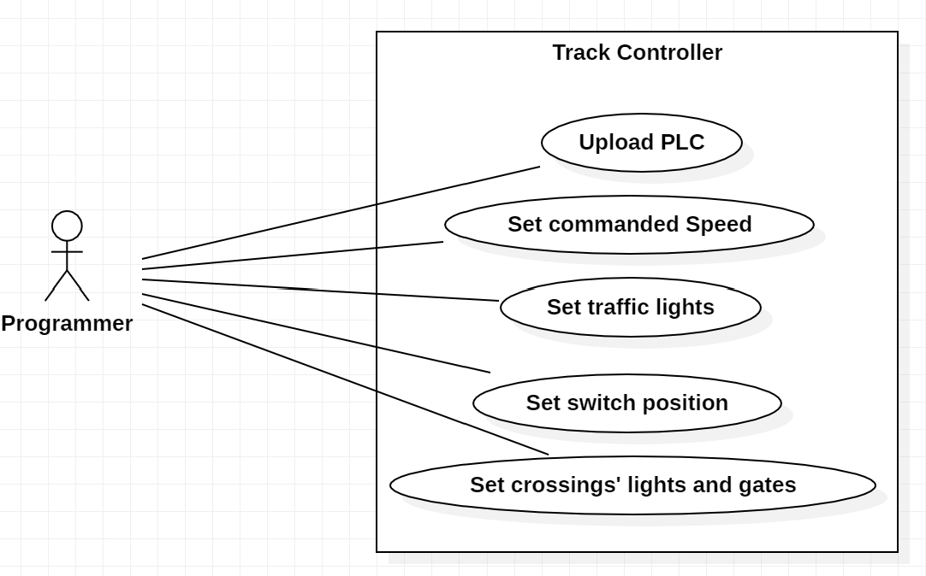

## 5.2.2.2 Hardware

## 5.2.2.1.1 Use Case Description

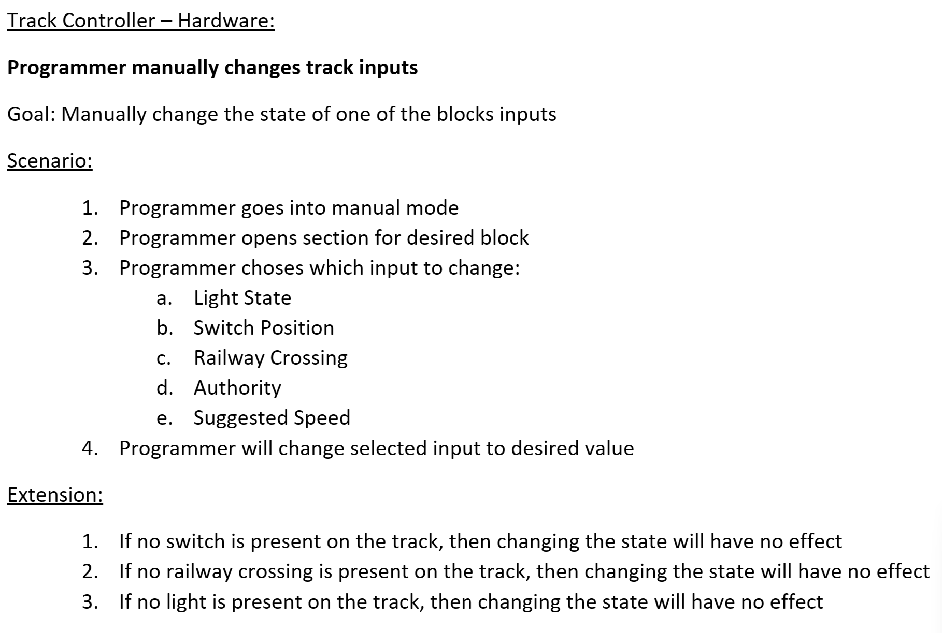

## 5.2.2.1.2 Use Case Diagram

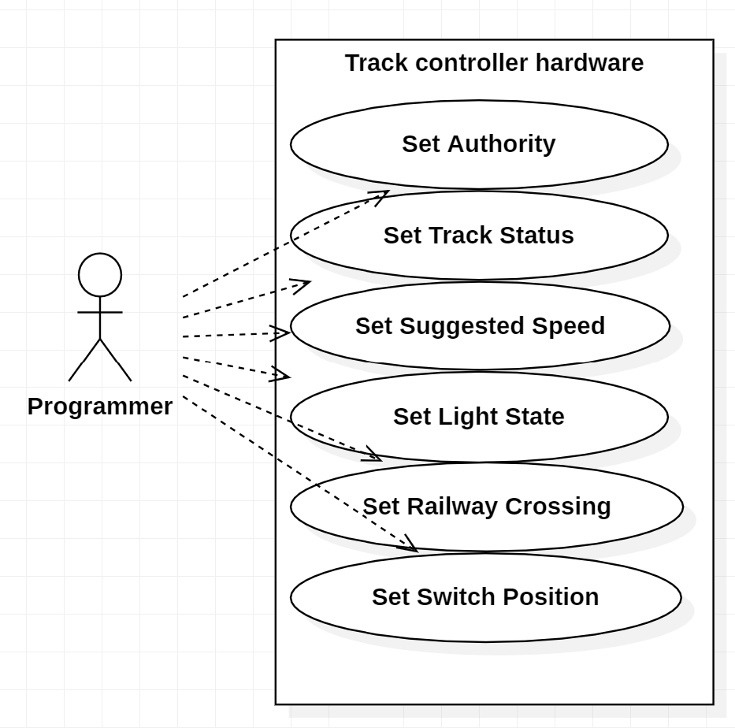

## 5.2.3 Track Model

## 5.2.3.1 Use Case Description

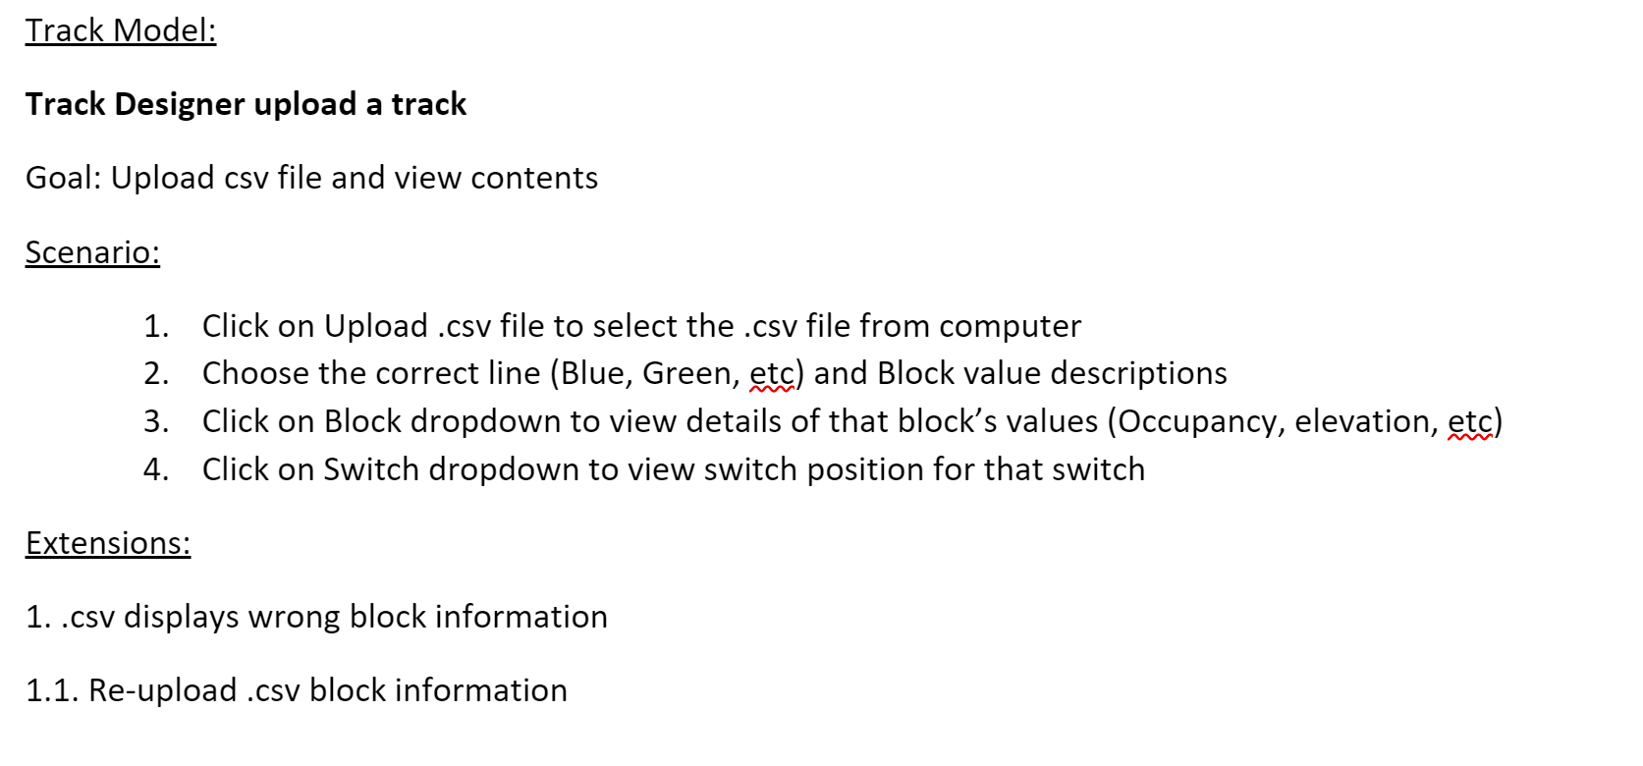

## 5.2.3.2 Use case Diagram

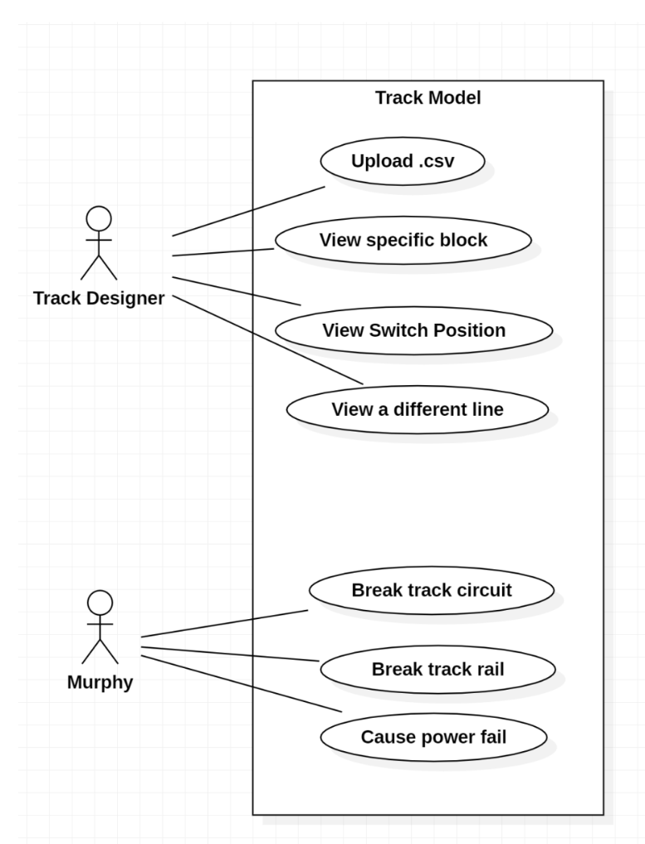

## 5.2.4 Train Model

## 5.2.4.1 Use Case Description 5.2.4.2 Use Case Diagram

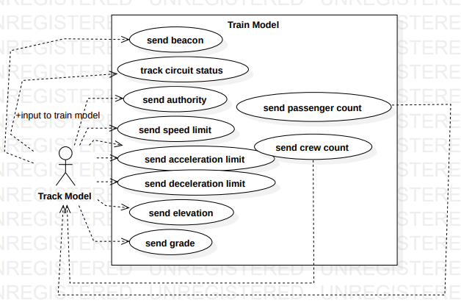

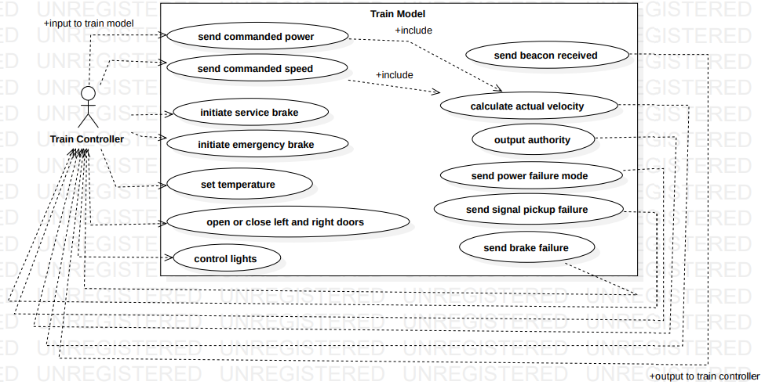

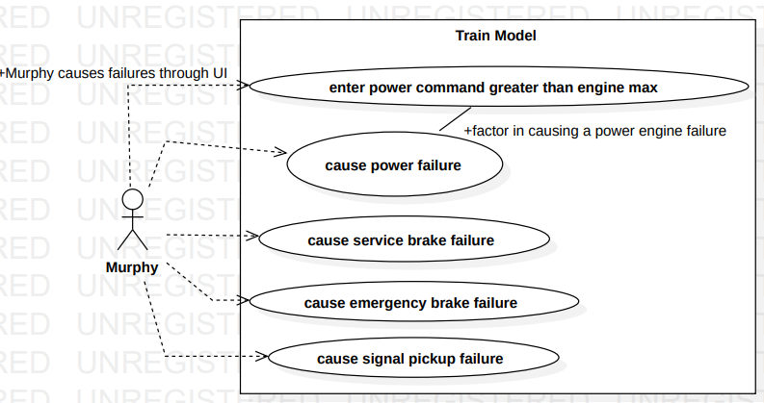

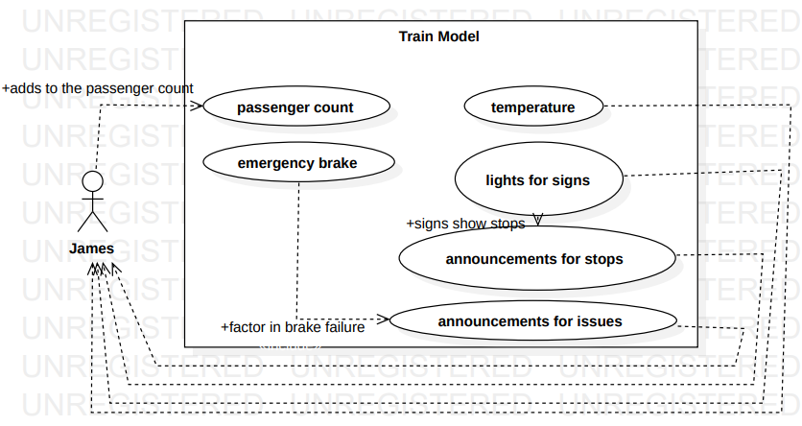

## 5.2.5 Train Controller

## 5.2.5.1 Use Case Description

Train Controller:

Goal: Train driver controls the train.

Scenario:

1. Engineer sets KP and KI
2. Train driver selects automatic or manual mode.
3. When in automatic mode, the train driver sets the speed of the train.
4. Controller displays power calculated from commanded speed and train’s actual speed, respecting authority and speed limit.
5. Train driver controls inputs to train, including service brake, emergency brake, lights, and doors.
6. System responds to train driver’s input.
7. Train announces and stops at stations.

Extensions:

1. Faults are reflected to driver and acted upon in a safe manner

## 5.2.5.2 Use Case Diagram

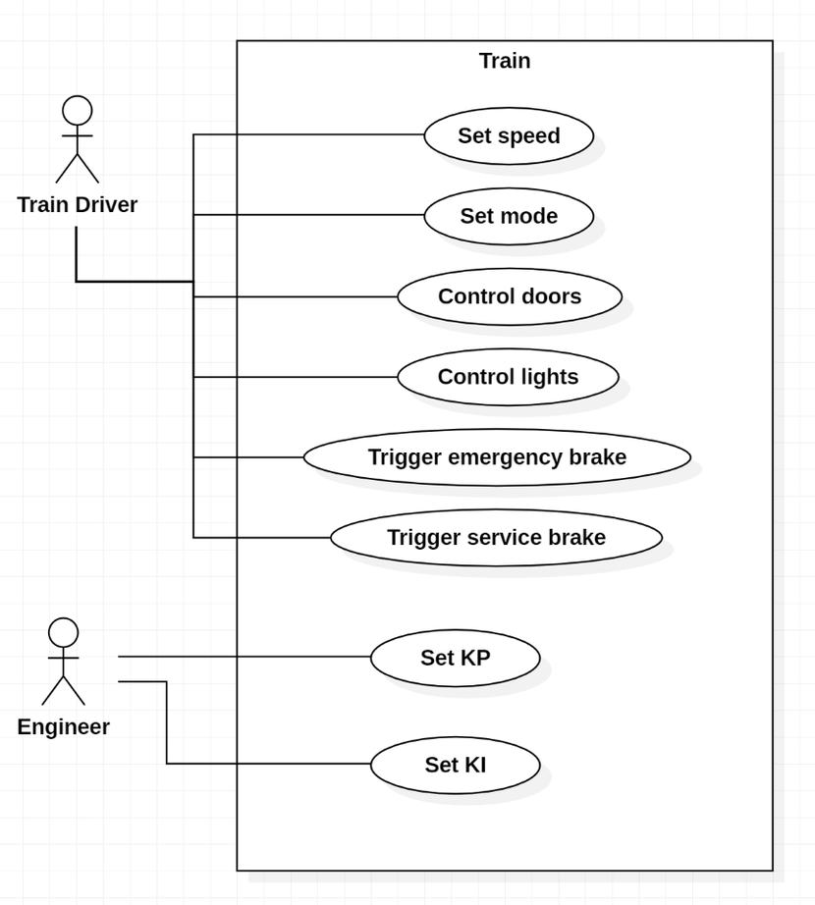

## 5.3 Composition viewpoint

The purpose of the composition viewpoint of the **renovated Centralized Traffic Control Center (CTC) and Signaling System for Light Rail Transit System** is to define the system as a composition of its subsystems. The project is formed by 5 main submodules: CTC office, wayside controller, track model, train model, and train controller. Detailed explanations about the relations between these modules will be explained in coming sections.

## 5.3.1.1 Deployment Diagram

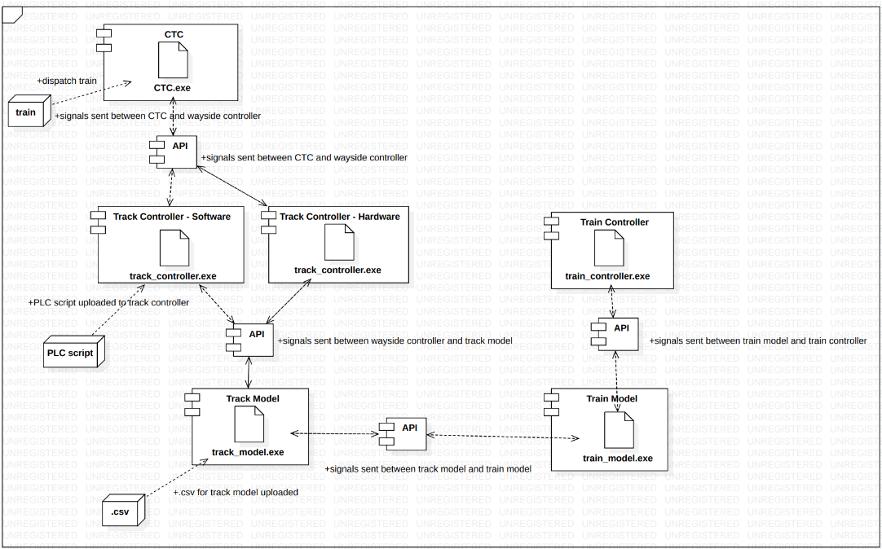

## 5.4 Logical viewpoint

The purpose of the Logical viewpoint is to elaborate existing and designed types and their implementations as classes and interfaces with their structural static relationships. For each entity, there will be a diagram to overview the entity and then a table that name, return type; visibility of the entity/class diagram is shown in. Also, definition of each element is provided. After all elements are explained, the class diagram that shows relationships between the classes is drawn.

## 5.4.1 CTC Office

## 5.4.1.1 Class Diagram

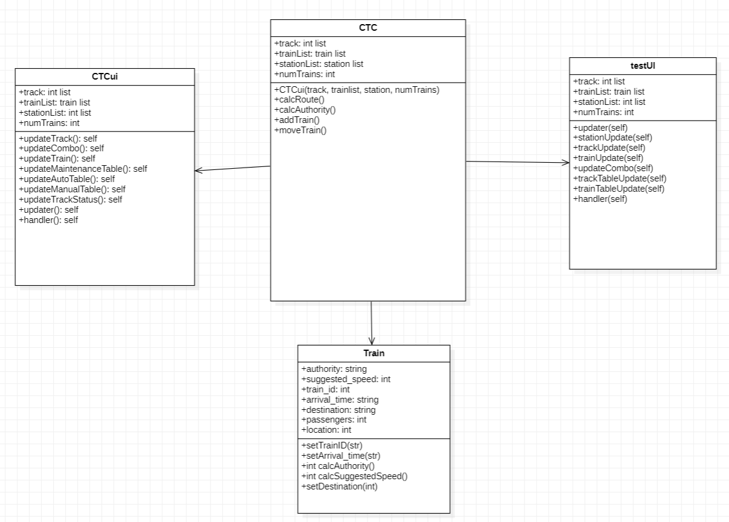

## 5.4.2 Wayside Controller

## 5.4.2.1 Software

## 5.4.2.1.1 Class Diagram

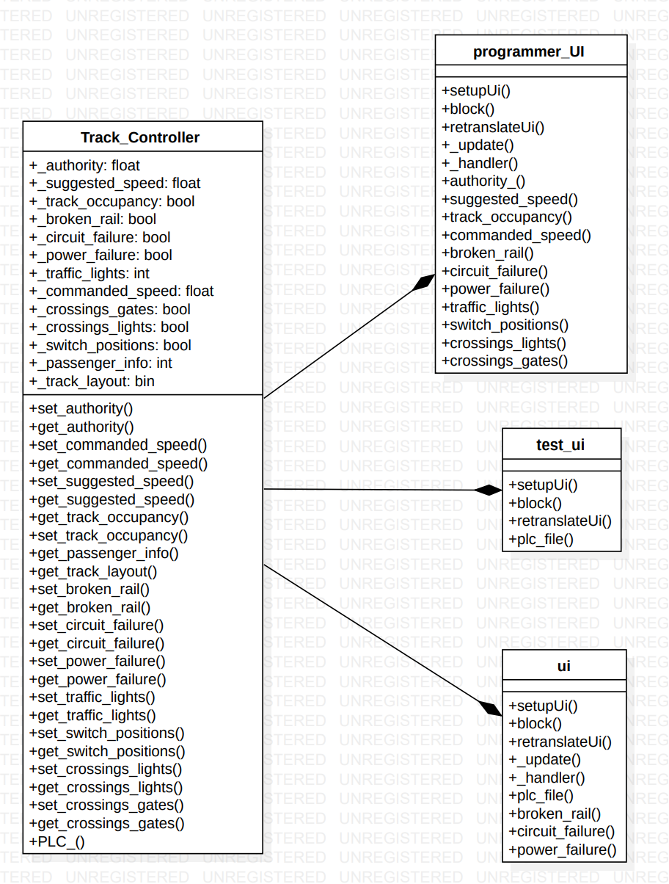

## 5.4.2.2 Hardware

## 5.4.2.2.1 Class Diagram

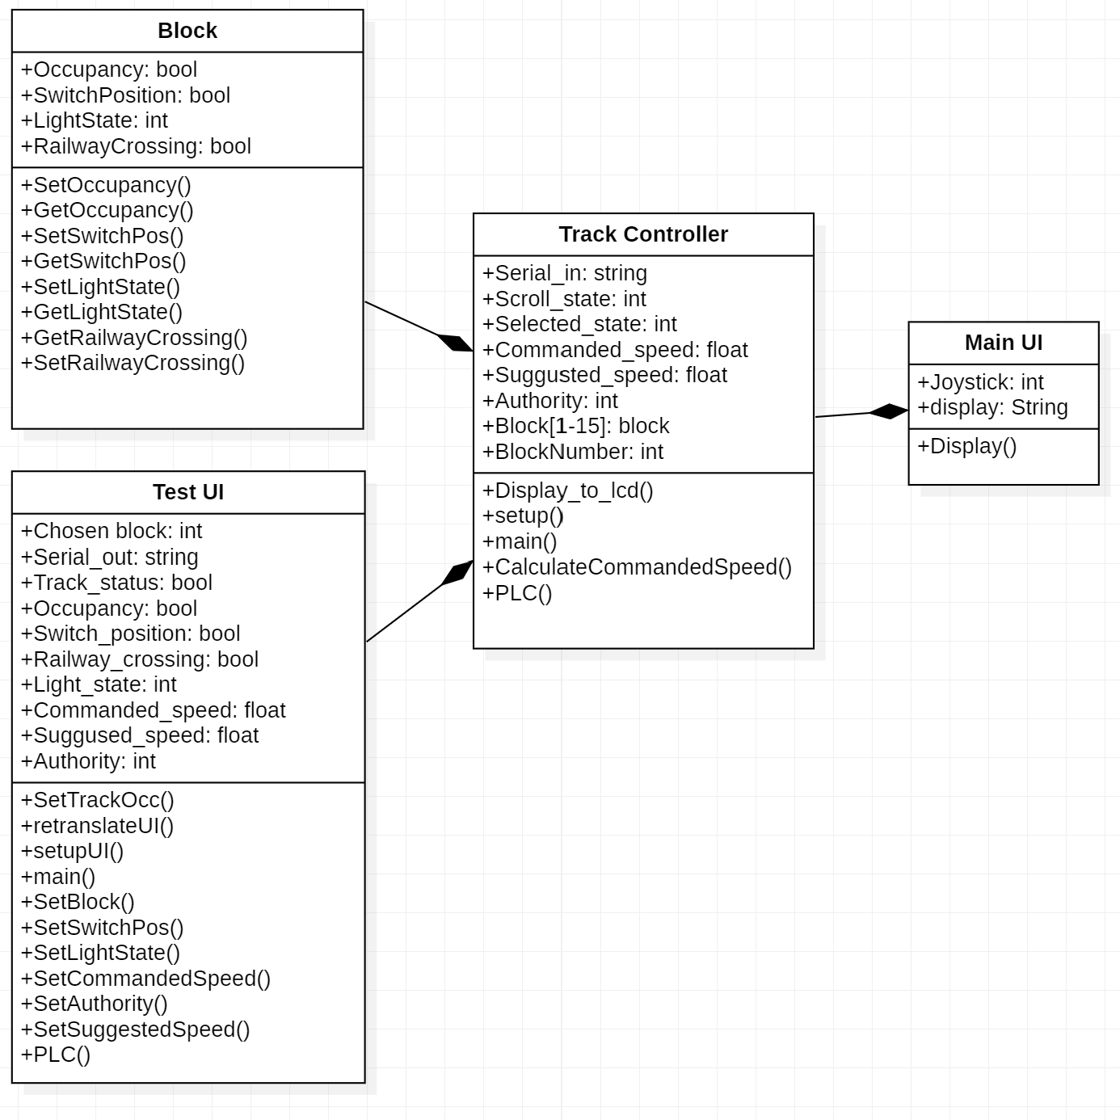

## 5.4.3 Track Model

## 5.4.3.1 Class Diagram

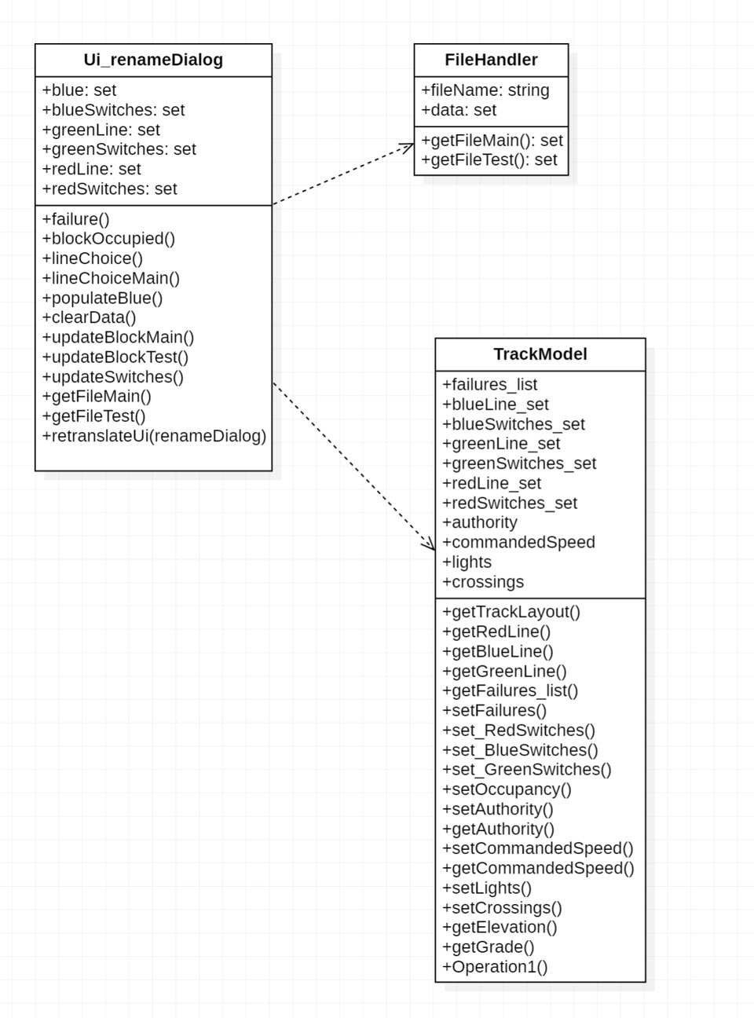

## 5.4.4 Train Model

## 5.4.4.1 Class Diagram

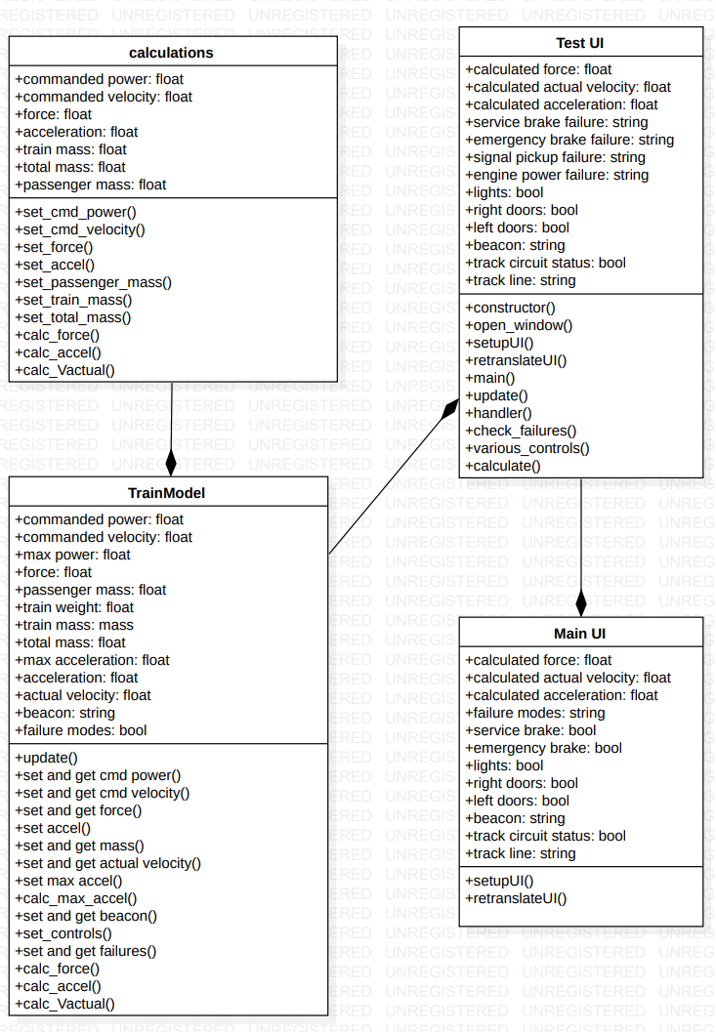

## 5.4.5 Train Controller

## 5.4.5.1 Class Diagram

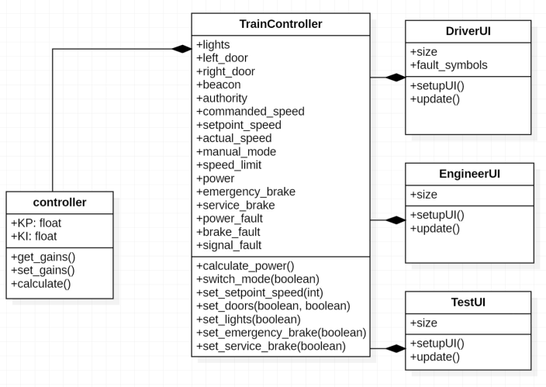

## 5.5 Dependency viewpoint

The Dependency viewpoint specifies the relationships of interconnection and access among entities. These relationships include shared information, order of execution, or parameterization of interfaces.

A Dependency view provides an overall picture of the design subject in order to assess the impact of requirements or design changes. It can help maintainers to isolate entities causing system failures or resource bottlenecks. It can aid in producing the system integration plan by identifying the entities that are needed by other entities and that must be developed first. This description can also be used by integration testing to aid in the production of integration test cases.

## 5.5.1 CTC Office

## 5.5.1.1 System Architecture

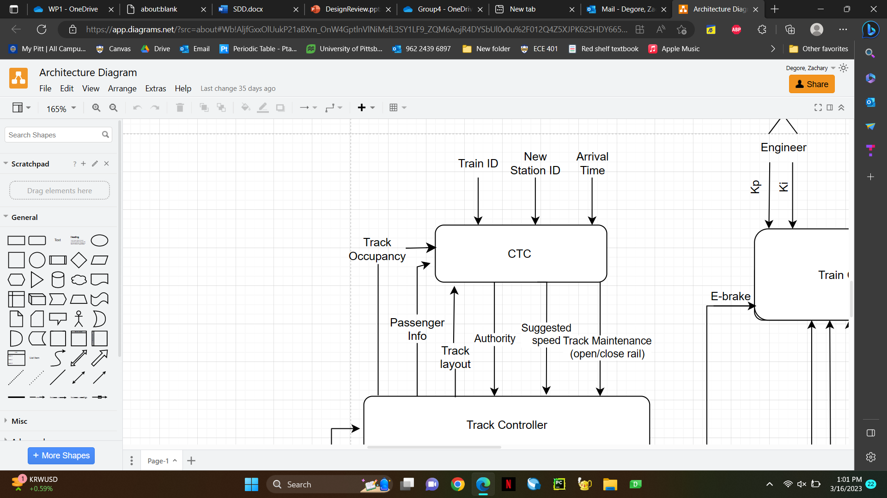

## 5.5.2 Wayside Controller

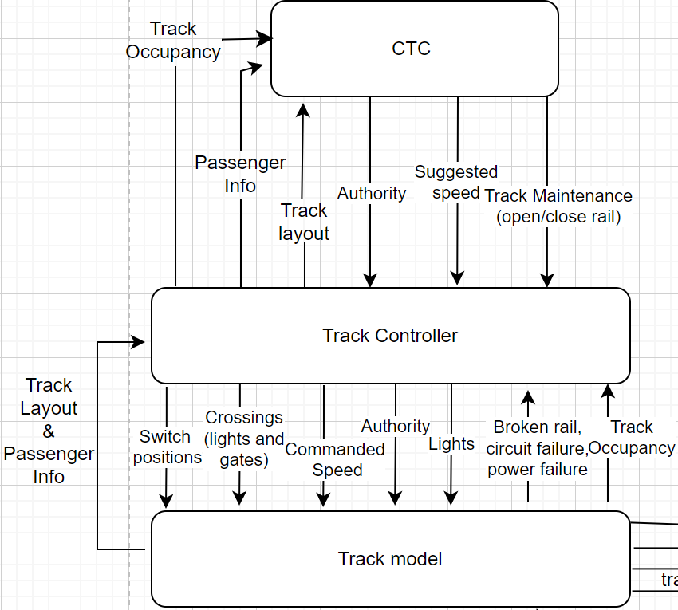

## 5.5.3 Track Model

## 5.5.3.1 System Architecture

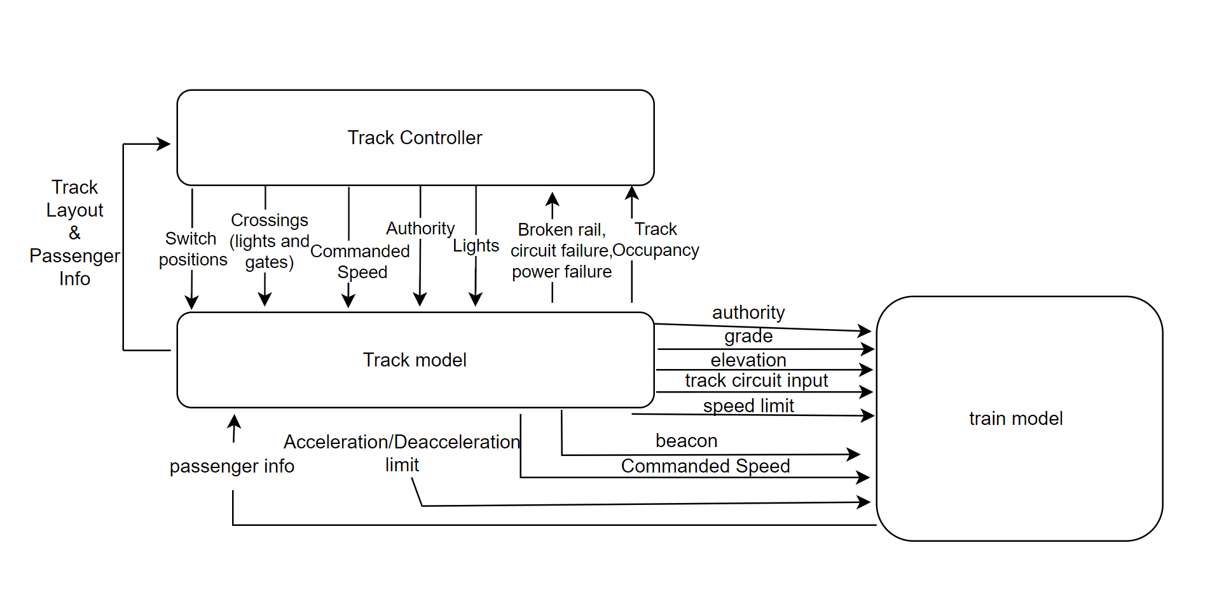

## 5.5.4 Train Model

## 5.5.4.1 System Architecture

## 5.5.5 Train Controller

## 5.5.5.1 System Architecture

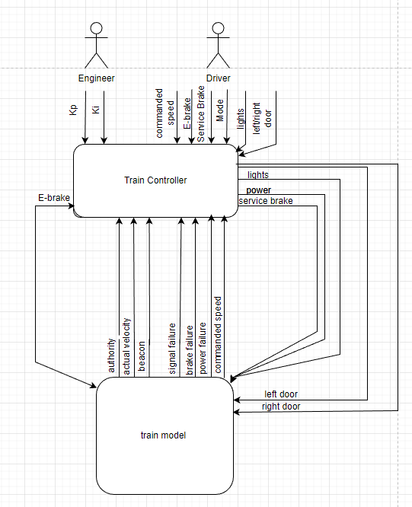

## 5.6 Information viewpoint

The Information viewpoint is applicable when there is a substantial persistent data content expected with the design subject.

## 5.7 Patterns use viewpoint

This viewpoint addresses design ideas (emergent concepts) as collaboration patterns involving abstracted roles and connectors.

## 5.8 Interface viewpoint

In this section, the details of external and internal interfaces will be defined. There shall be user interfaces for each sub-module in the **renovated Centralized Traffic Control Center (CTC) and Signaling System for Light Rail Transit System**. All communication related to Arduino board will be established via USB.

## 5.8.1 CTC Office

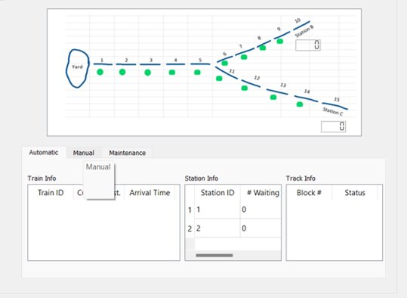

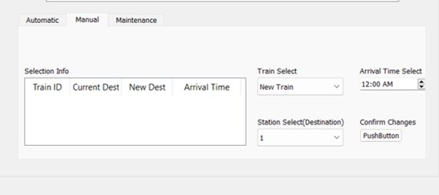

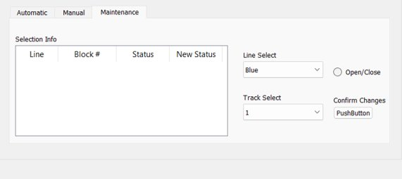

## 5.8.2 Wayside Controller

## 5.8.2.1 Software

## 5.8.2.1.1 Test User Interface

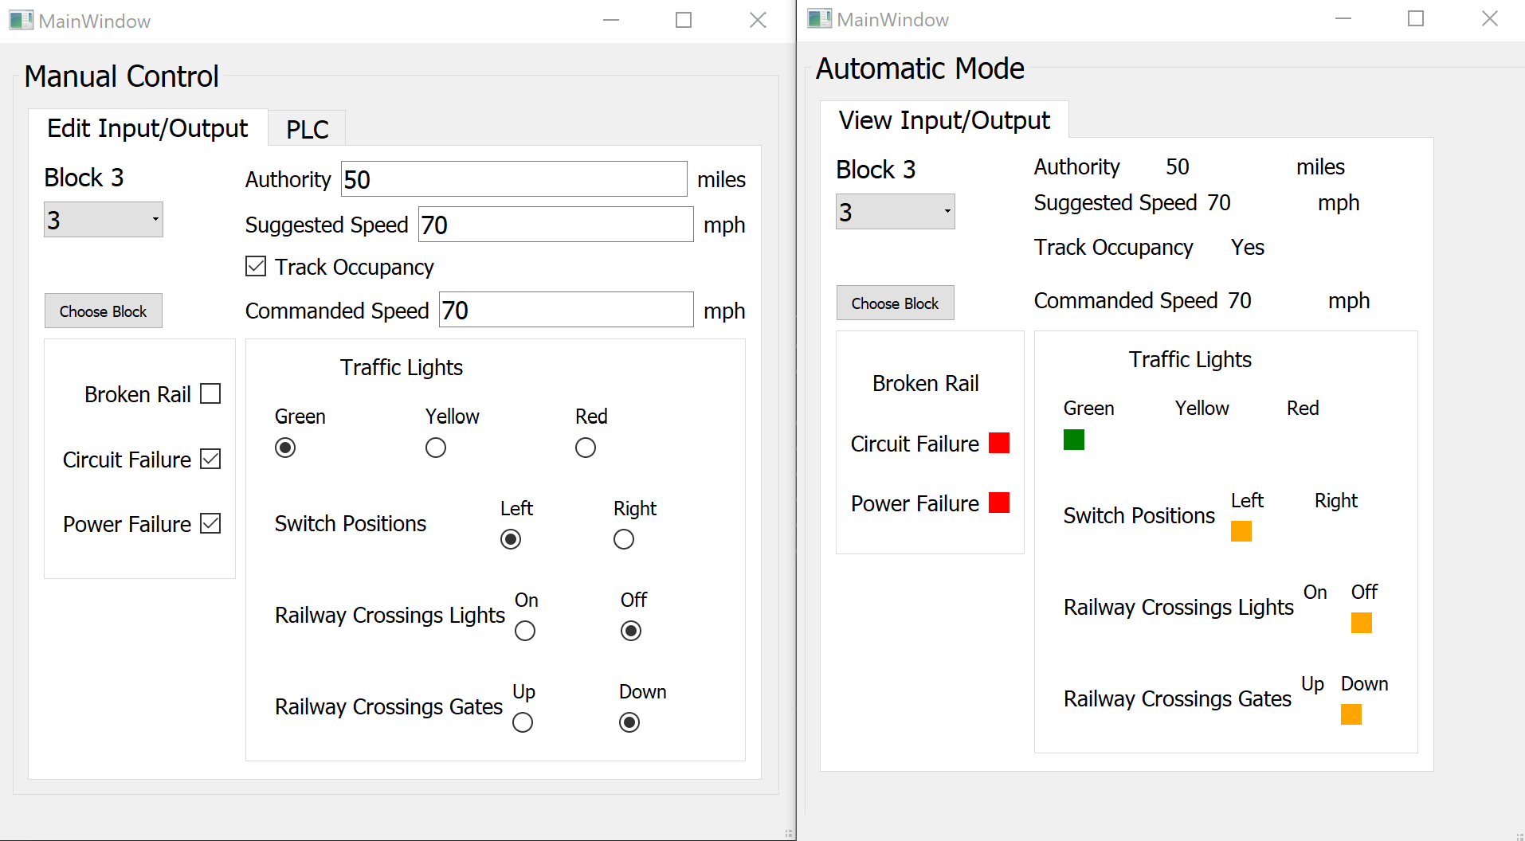

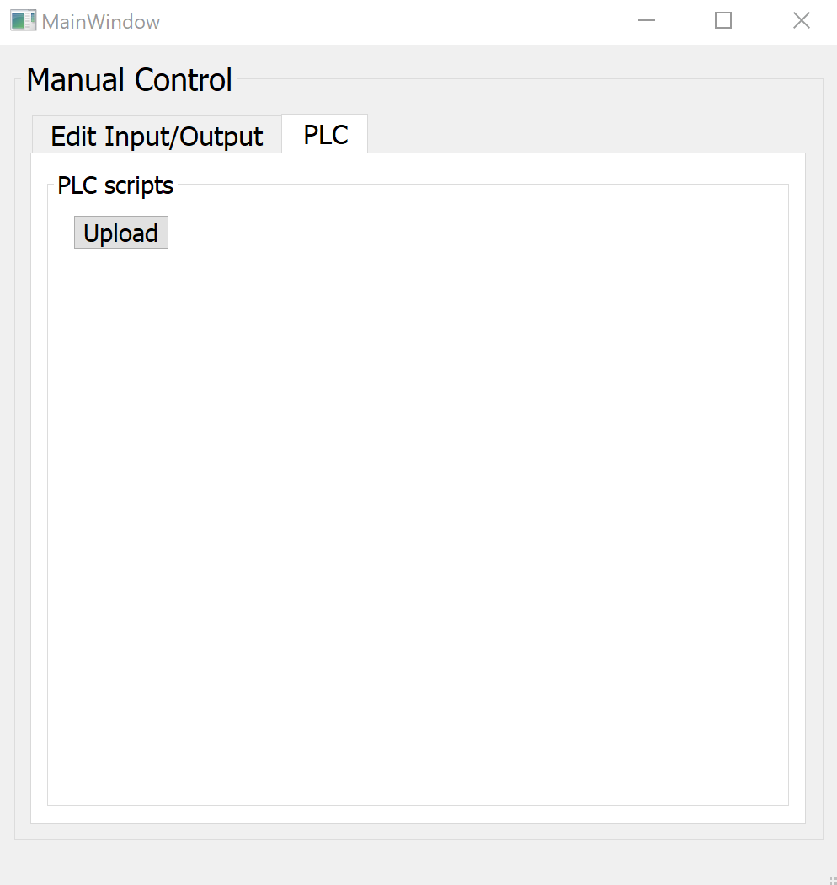

## 5.8.2.1.2 User Interface (Programmer’s)

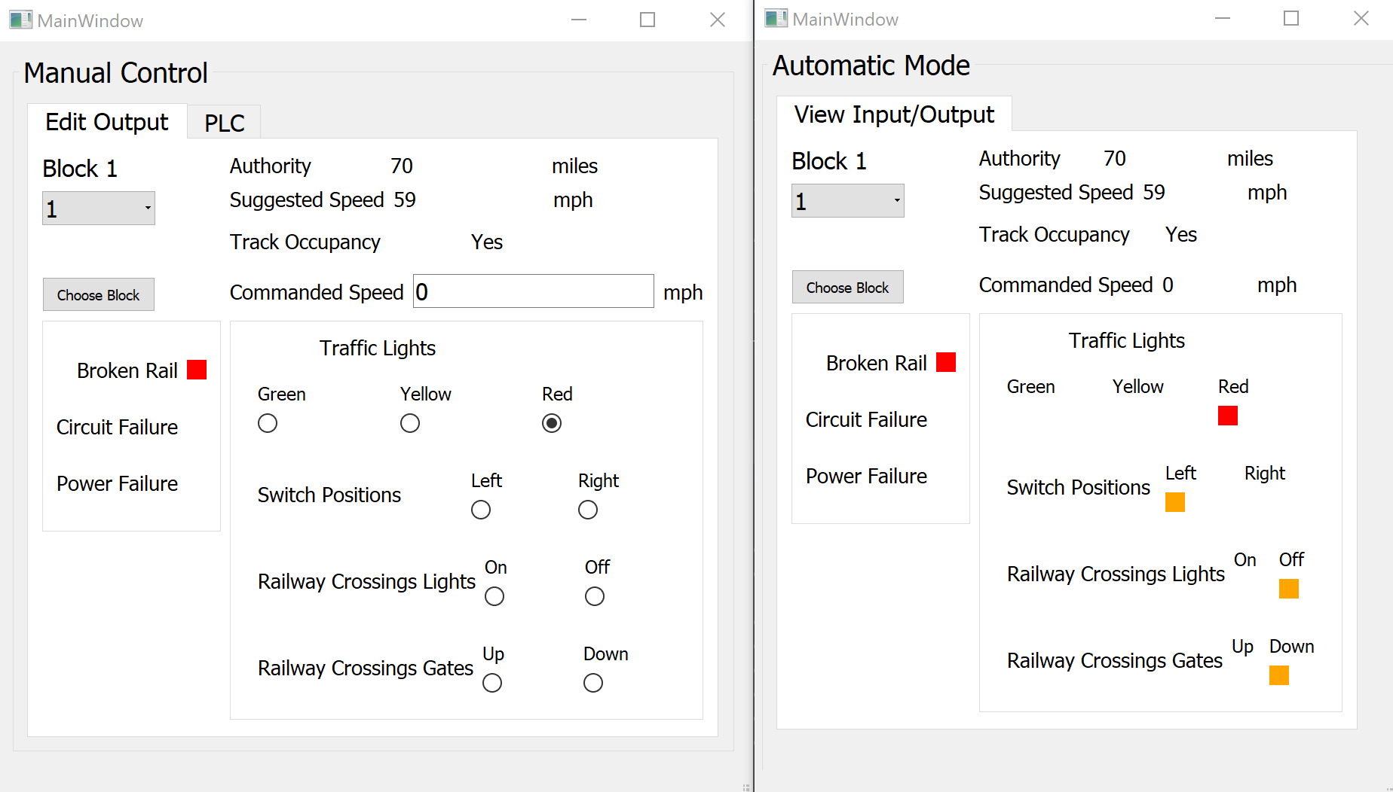

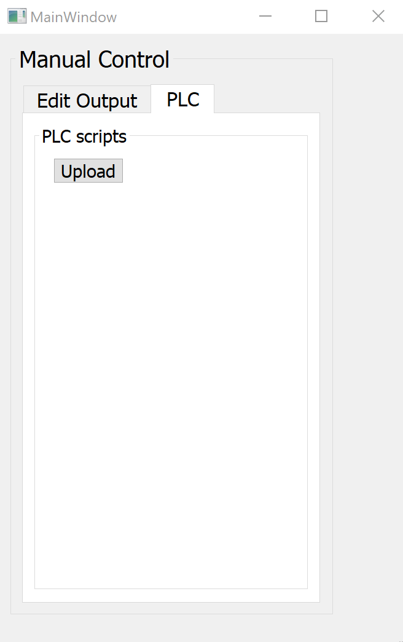

## 5.8.2.2 Hardware

## 5.8.2.2.1 Test User Interface

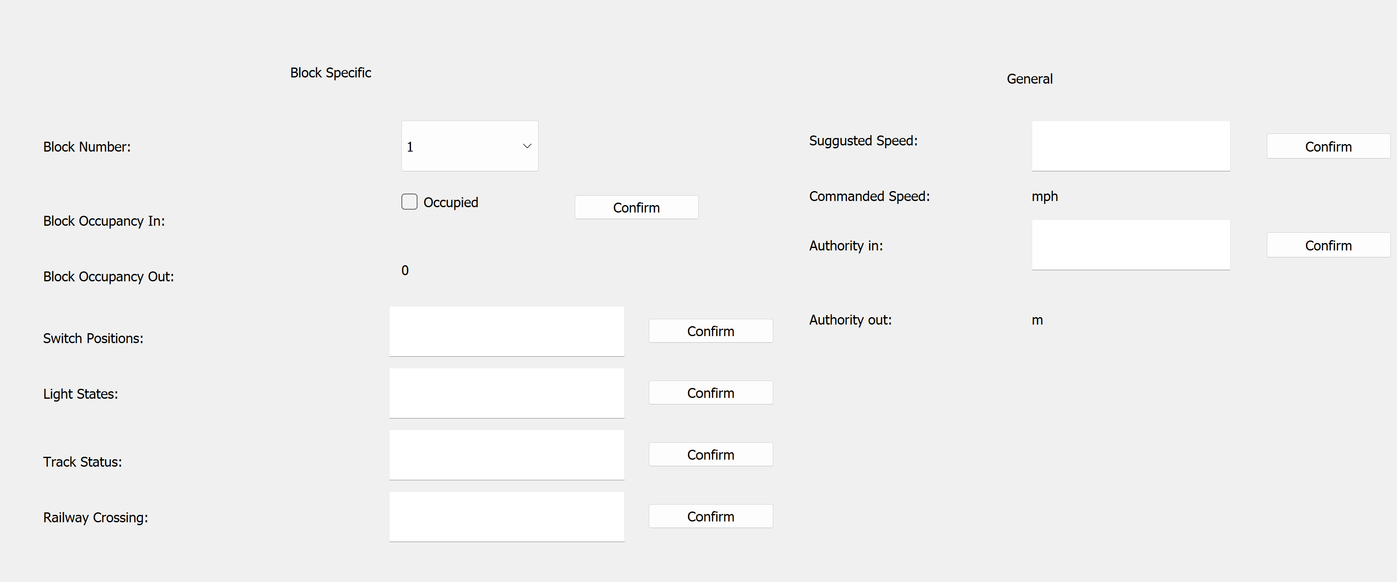

## 5.8.2.2.2 User Interface

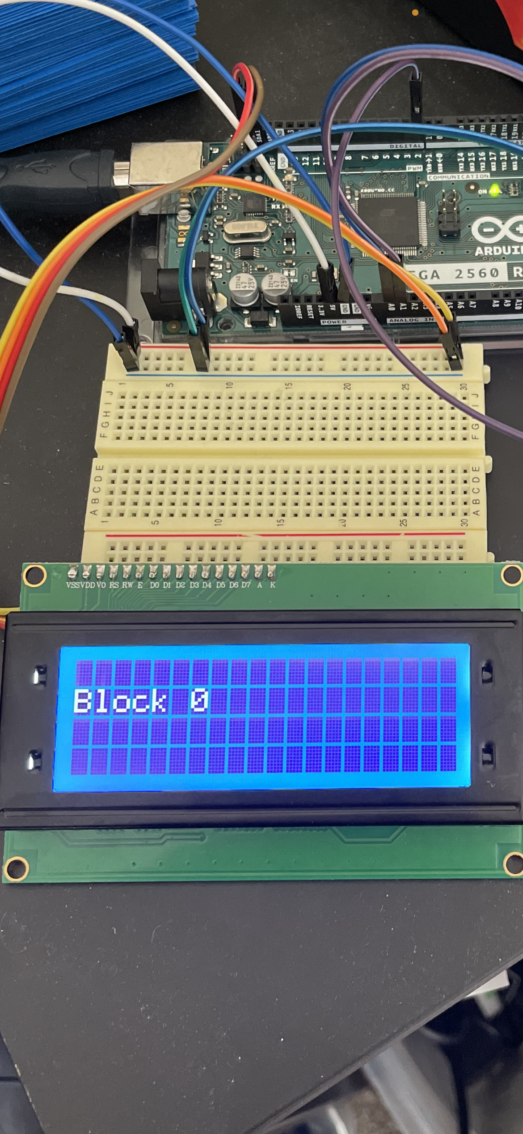

## 5.8.3 Track Model

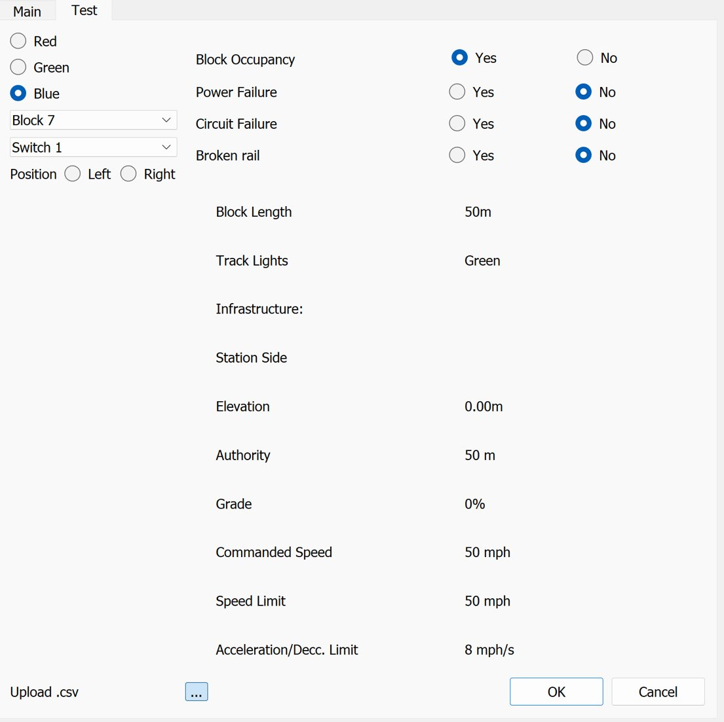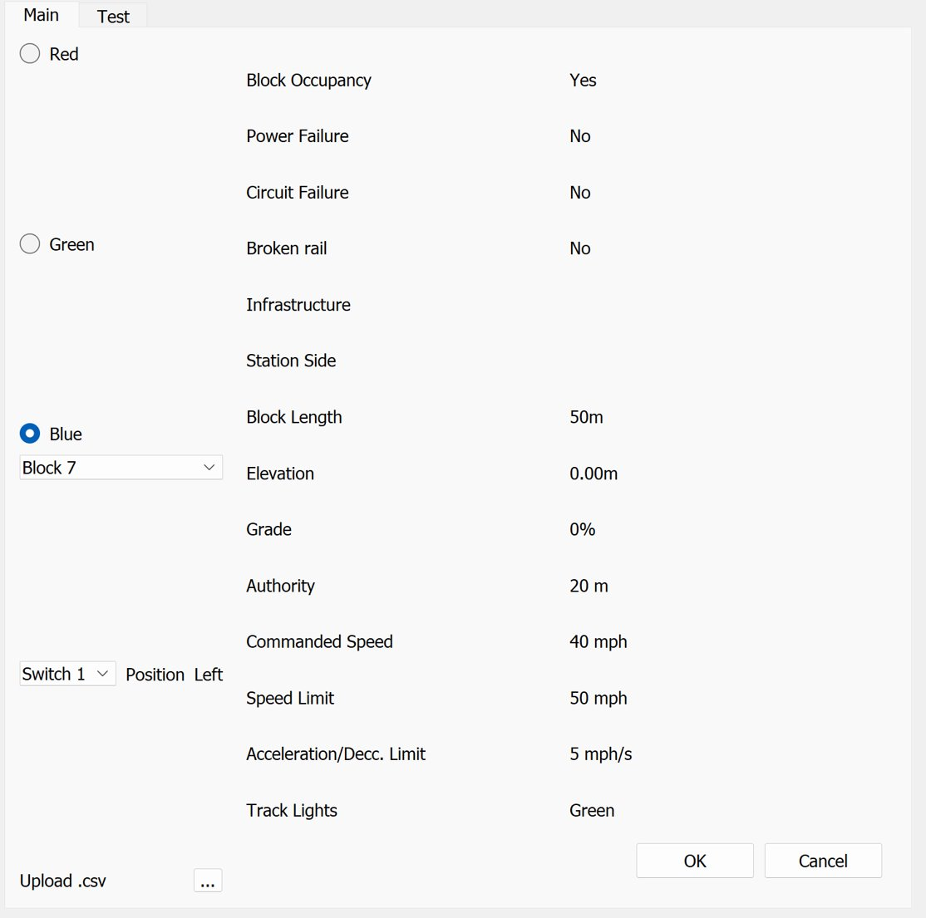

## 5.8.4 Train Model

## 5.8.4.1 Test User Interface

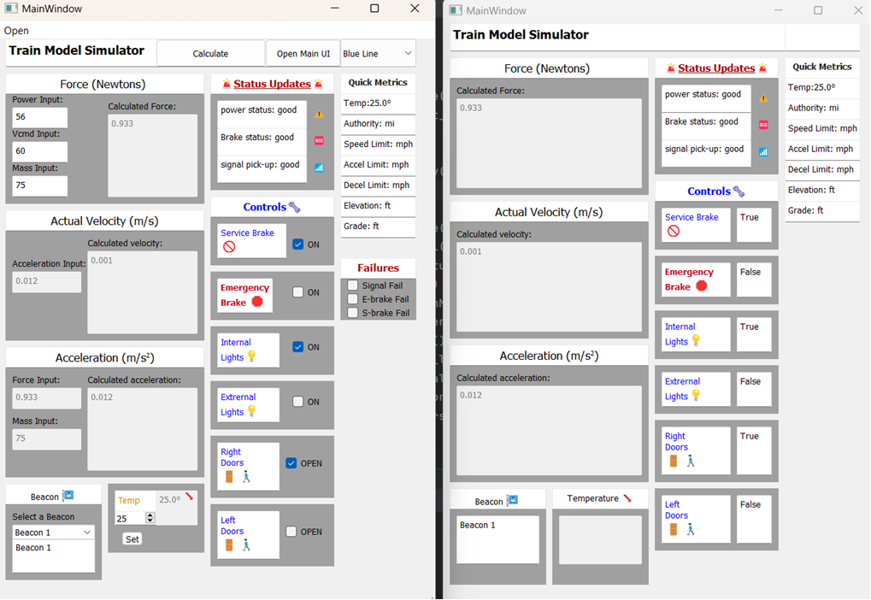

## 5.8.4.2 Train Model User Interface



## 5.8.5 Train Controller

## 5.8.5.1 Engineer’s UI:

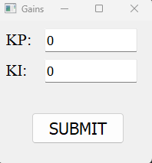

5.8.5.2 Train Driver’s UI:

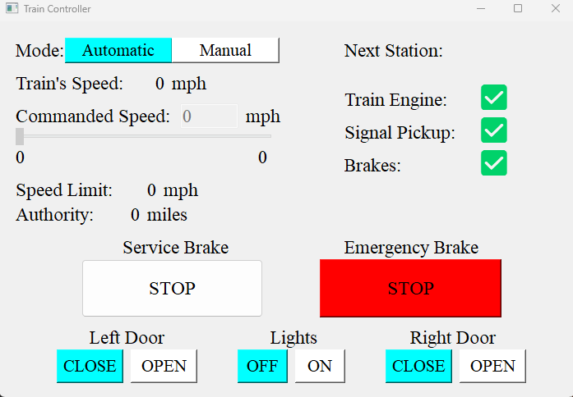

## 5.9 Structure viewpoint

Structure viewpoint informs user and the developer about the interaction between the packages in the system.

## 5.10 Interaction viewpoint

In this section, the main functionalities of the system are given by the help of sequence diagrams. Moreover, it defines strategies for interaction among entities.

## 5.10.1 CTC Office

## 5.10.1.1 Sequence Diagram

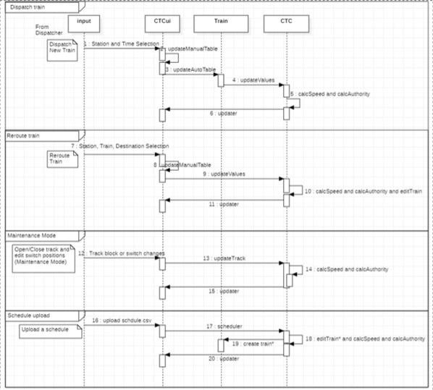

## 5.10.2 Wayside Controller

## 5.10.2.1 Software

## 5.10.2.1.1 Sequence Diagram

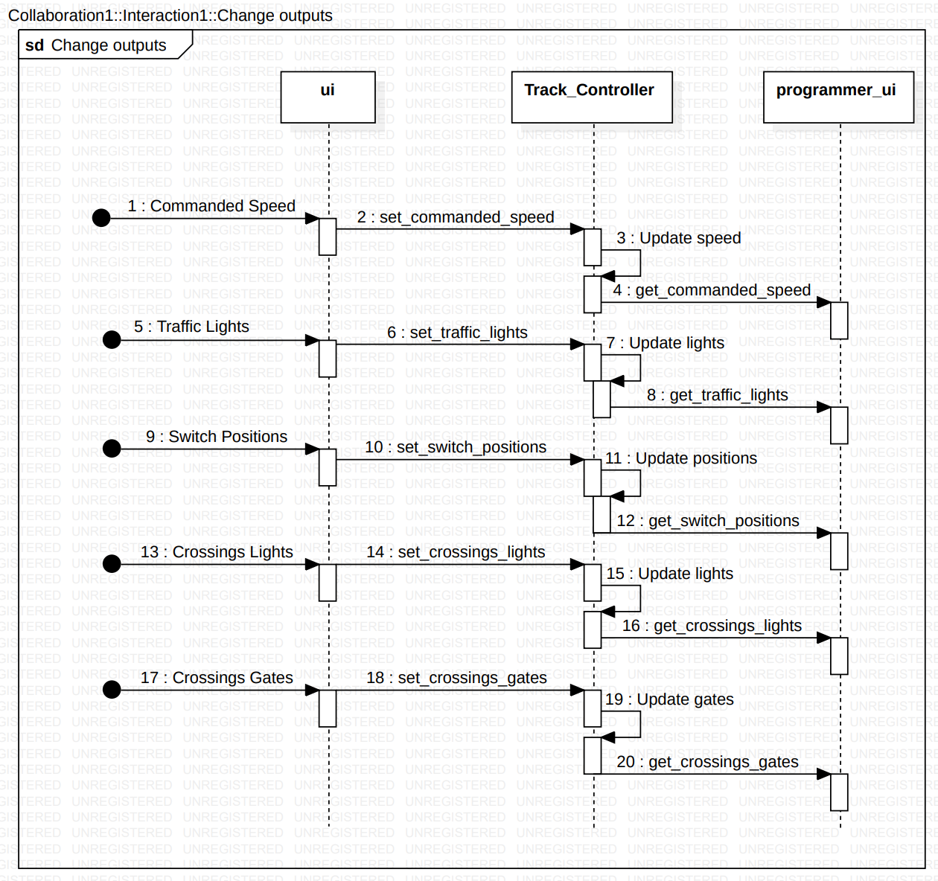

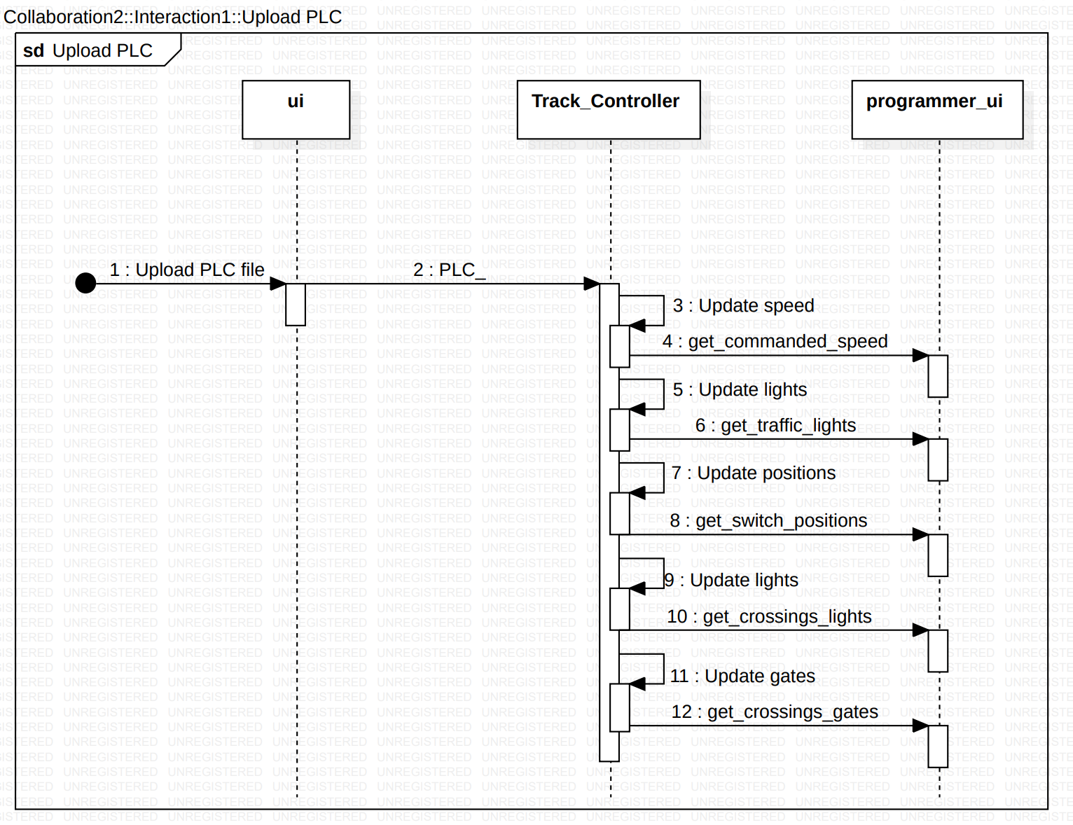

## 5.10.2.2 Hardware

## 5.10.2.2.1 Sequence Diagram

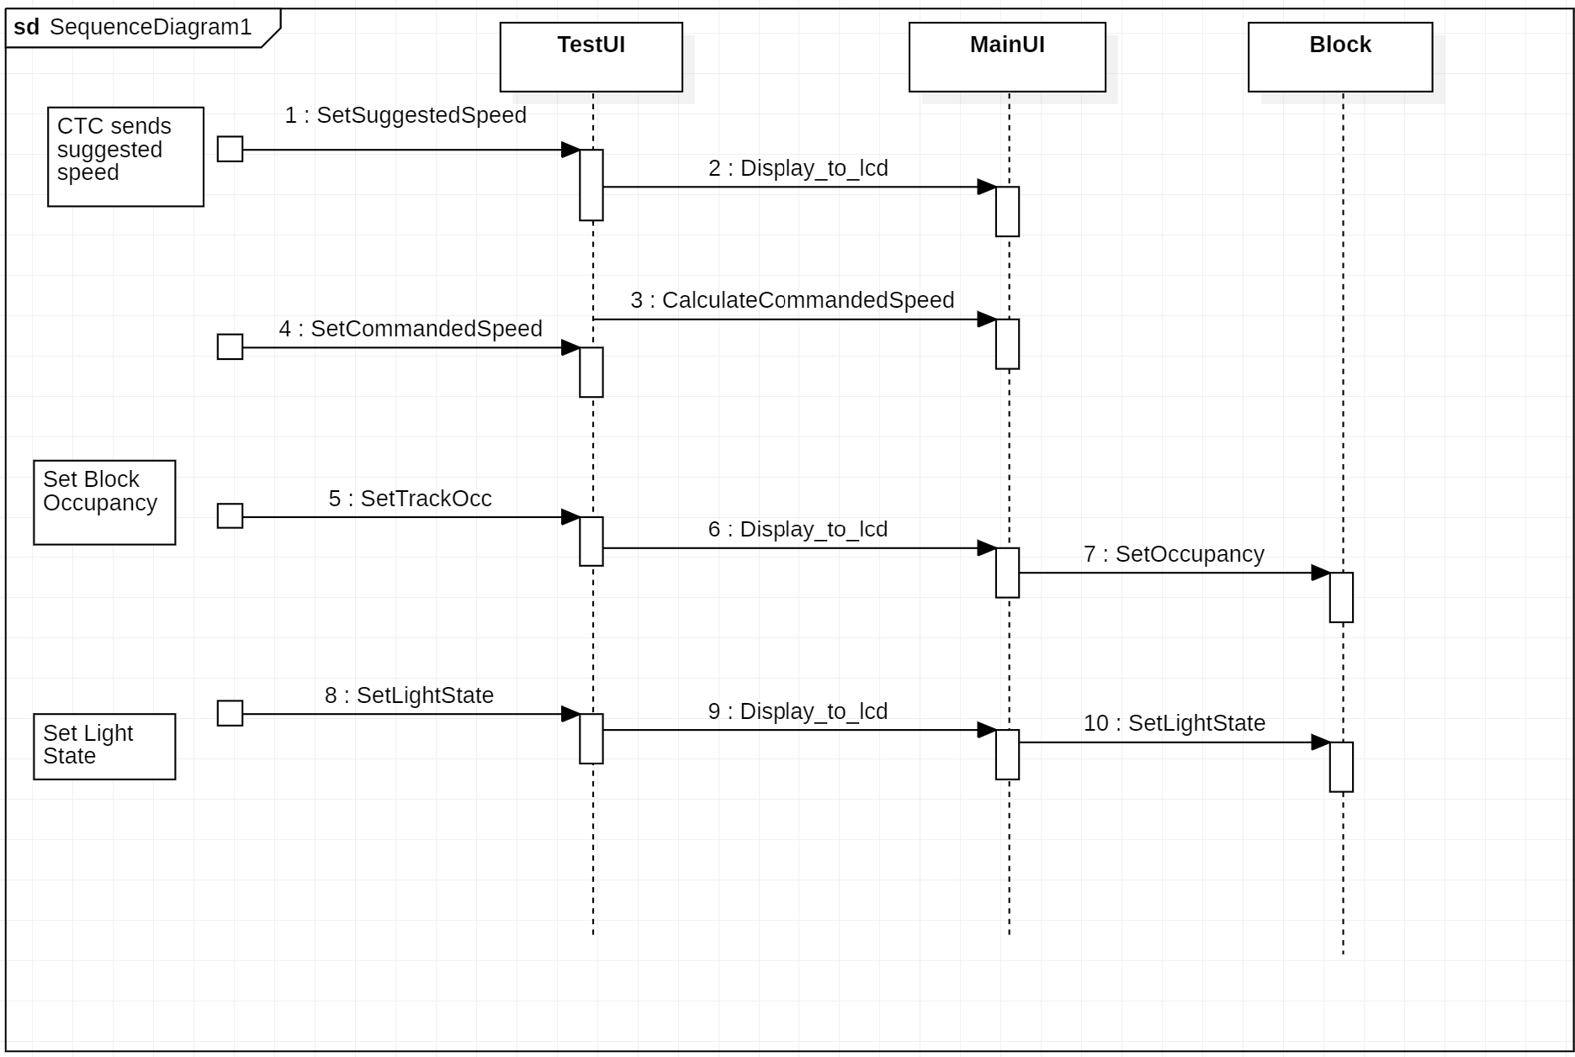

## 5.10.3 Track Model

## 5.10.3.1 Sequence Diagram

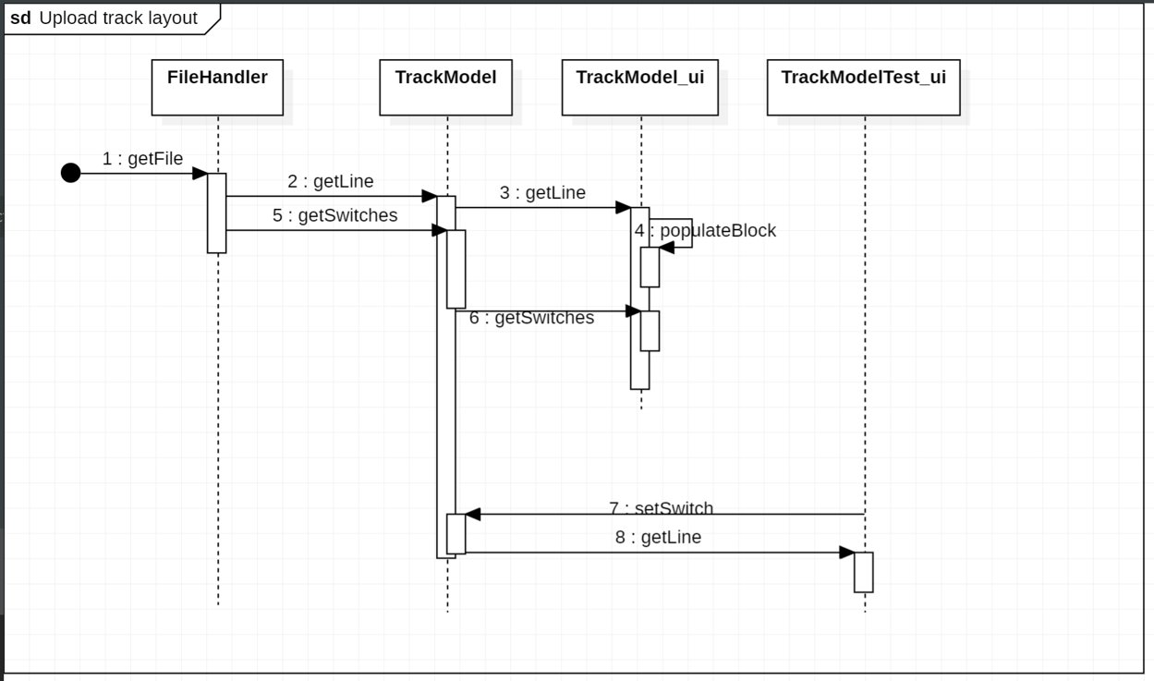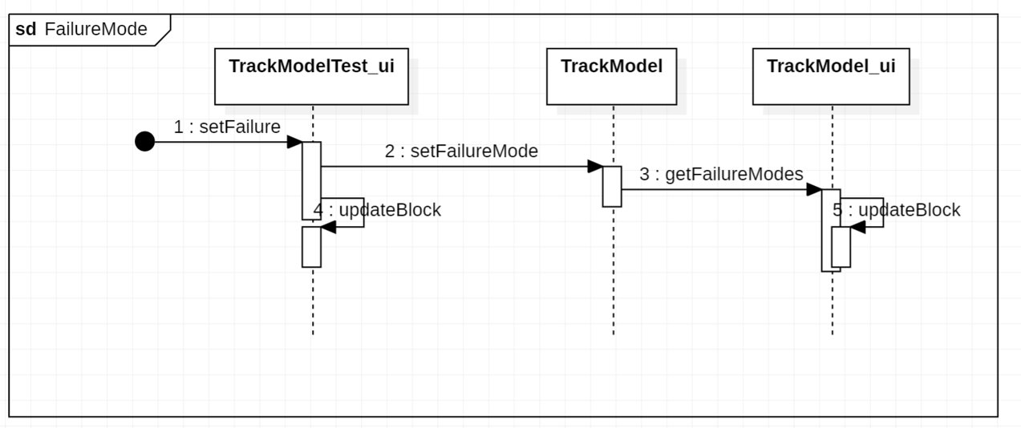

## 5.10.4 Train Model

## 5.10.4.1 Sequence Diagram

## 5.10.5 Train Controller

## 5.10.5.1 Sequence Diagram

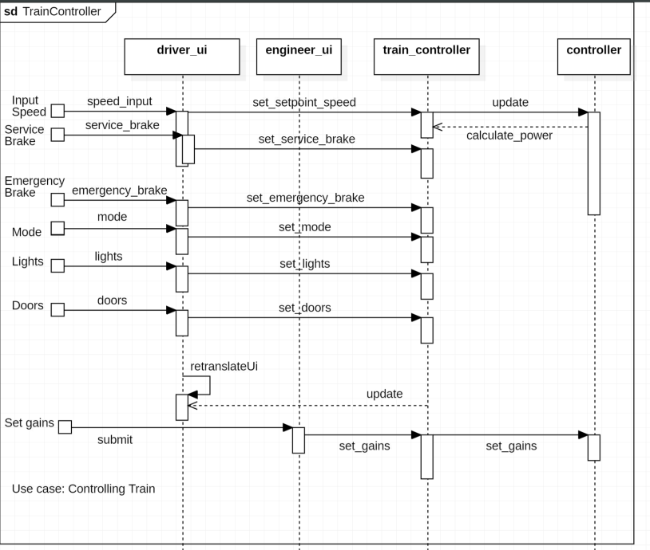

## 5.11 State dynamics viewpoint

Reactive systems and systems whose internal behavior is of interest use this viewpoint.

## 5.12 Algorithm Viewpoint

The detailed design description of operations (such as methods and functions), the internal details and logic of each design entity.

## 5.12.1 CTC Office

## 5.12.1.1 Apportionment

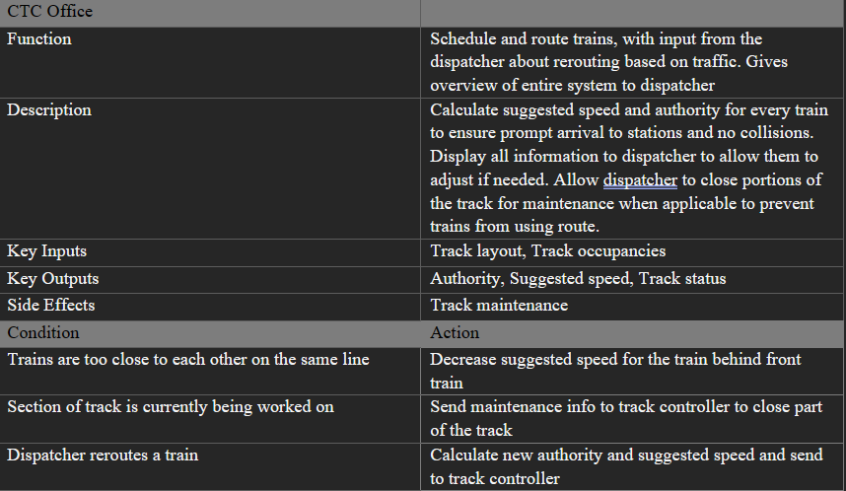

## 5.12.2 Wayside Controller

## 5.12.2.1 Apportionment

## 5.12.3 Track Model

## 5.12.3.1 Apportionment

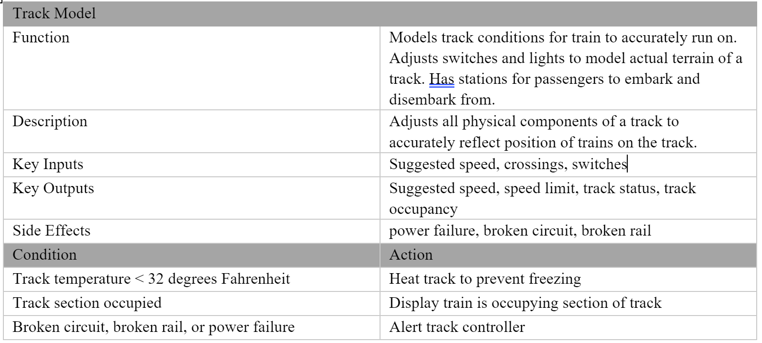

## 5.12.4 Train Model

## 5.12.4.1 Apportionment

## 5.12.5 Train Controller

## 5.12.5.1 Apportionment

|  |  |
| --- | --- |
| Train Controller | |
| Function | Vital controller that controls the train’s speed according to speed limit and authority. Also allows for train drivers to control the train. |
| Description | Receives actual speed from train model and regulates the train speed using a PI controller to the commanded speed of the driver or CTC office. Acts upon faults in a safe manner using emergency brake. Also controls non-vital components such as lights, doors, and station announcing. |
| Key Inputs | Commanded speed, Actual speed, Authority, Beacon, Speed limit, Brake failure, Engine failure, Signal failure |
| Key Outputs | Train power, Emergency Brake, Service Brake |
| Side Effects | Emergency Brake |
| Condition | Action |
| Brake failure, engine failure, or signal failure | Emergency brake applied |
| Train going too slow | More power applied |
| Train going too fast | Power reduced and service brake applied |
| Train arrives at station | Station announced and appropriate doors are opened |

## 5.13 Resource viewpoint

The purpose of the Resource viewpoint is to model the characteristics and utilization of resources in a design subject.

# 6. System Architecture

## 6.1 Route

Route dictates the path a train takes to reach its desired destination. CTC will create this and pass a suggested route to the wayside controller. The wayside controller will then output a commanded route to the train and track models. This will be implemented a list containing the line and associated blocks.

## 6.2 Authority

Authority dictates how far the train can travel at any given time. This is determined by "safe distance" between trains, accounting for deceleration rate and distance from the next train. CTC determines this based off track occupancy from the train model and train info from the train model. It’s represented as a string output from CTC, where the string denotes the block that the train has authority up to. This string is propagated from CTC to the track model. The track model then converts this into an integer by taking the distance between the occupied block and block the train has authority up to.

## 6.3 Wayside Distribution

Wayside distribution denotes the number of controllers distributed evenly across the track. One controller is placed every 15 blocks. Based off the Blue Line, this results in 17 controllers.

## 6.4 Timing

Timing denotes how the system keeps track of time. Since system time needs to be independent of wall time, CTC will store and increment time based on the selected simulation speed. This will be propagated to modules that need system time, such as Train Model and Train Controller, from CTC through the rest of the modules. Time will be represented by a variable of type unsigned integer.

## 6.5 Vitality

Vitality dictates how dependability is implemented in our system. This applies to vital modules, such as the train and track controllers. Both these controllers watch for faults from their respective models and act upon them accordingly. If a track fault is detected, this is indicated to CTC who will attempt to reroute the train. If a train fault is detected, the train controller will act upon the fault and stop the train.